

# 

### Semester One Examination, 2020

# MATHEMATICS

**SOLUTIONS**

**METHODS**

**UNIT 3**

## Section Two:

## Calculator-assumed

## Structure of this paper

|  |  |  |  |  |  |
| --- | --- | --- | --- | --- | --- |
| Section | Number of questions available | Number of questions to be answered | Working time (minutes) | Marks available | Percentage of examination |
| Section One: Calculator-free | 8 | 8 | 50 | 52 | 35 |
| Section Two: Calculator-assumed | 13 | 13 | 100 | 98 | 65 |
|  | | |  | **Total** | 100 |

This section has**thirteen** questions.

Question 9 (6 marks)

A seafood processor buys batches of $n$ prawns from their supplier, where $n$ is a constant. In any given batch, the probability that a prawn is export quality is $p$, where $p$ is a constant and the quality of an individual prawn is independent of other prawns.

The discrete random variable $X$ is the number of export quality prawns in a batch and the mean of $X$ is $220.5$ and standard deviation of $X$ is $5.25$.

(a) State the name given to the distribution of $X$ and determine its parameters $n$ and $p$.

(4 marks)

|  |
| --- |
| **Solution** |
| $X$ follows a binomial distribution. $$np=220.5 \\ np\left(1-p\right)={5.25}^{2}$$ $$n=252, p=\frac{7}{8}=0.875$$ |
| **Specific behaviours** |
| ✓ names binomial distribution  ü equation for mean and variance (or sd)  ü value of $n$ ü value of $p$ |

*Done well with almost everyone recognising it as a Binomial Distribution (but we haven’t done many others at this time of the year!). This should have been an easy 4 marks.*

(b) Determine the probability that less than $90\%$ of prawns in a randomly selected batch are export quality. (2 marks)

|  |
| --- |
| **Solution** |
| $$90\%×252=226.8$$ $$P\left(X≤226\right)=0.8753$$ |
| **Specific behaviours** |
| ✓ lower bound  ü probability |

*Failure to work out what number of prawns were part of the calculation proved costly. Obviously, no follow-through marks could be considered.*

Question 10 (8 marks)

A small body moving in a straight line has displacement $x$ cm from the origin at time $t$ seconds given by

$$x=4\cos\left(3t-6\right)-1.5, 0≤t≤3.$$

(a) Use derivatives to justify that the maximum displacement of the body occurs when $t=2$.

(4 marks)

|  |
| --- |
| **Solution** |
| $$\frac{dx}{dt}=-12\sin\left(3t-6\right) \\ t=2⇒\frac{dx}{dt}=-12\sin\left(0\right)=0$$ Hence when $t=2, x$ has a stationary point. $$\frac{d^{2}x}{dt^{2}}=-36\cos\left(3t-6\right) \\ t=2⇒\frac{d^{2}x}{dt^{2}}=-36\cos\left(0\right)=-36$$ Since second derivative is negative, the stationary point is a maximum, and so the body has a maximum displacement when $t=2$. |
| **Specific behaviours** |
| ✓ first derivative  ü indicates stationary point at required time  ü value of second derivative at required time  ü statement that justifies maximum |

*It is surprising that students cannot differentiate simple trig functions – or keep the variables that appear in the question! The requirement to prove the stationary point is ever present and this should have been obvious given the mark allocation for this part of the question.*

(b) Determine the time(s) when the velocity of the body is not changing. (2 marks)

|  |
| --- |
| **Solution** |
| $$a=\frac{d^{2}x}{dt^{2}}=-36\cos\left(3t-6\right)$$ $$a=0⇒\cos\left(3t-6\right)=0$$ $$t=2-\frac{π}{2},2- \frac{π}{6}, 2+\frac{π}{6}≈0.429, 1.476, 2.524 \text{seconds}$$ |
| **Specific behaviours** |
| ✓ indicates acceleration/second derivative must be zero  ü states exact (or approximate) times in interval |

*This was done quite well by those who can differentiate trig functions and understand the relationship between trig angles in a unit circle. Or, can use their ClassPads!*

(c) Express the acceleration of the body in terms of its displacement $x$. (2 marks)

|  |
| --- |
| **Solution** |
| $$a=-36\cos\left(3t-6\right) \\ =-9\left(4\cos\left(3t-6\right)\right) \\ =-9\left(x+1.5\right)$$ |
| **Specific behaviours** |
| ✓ factors out $-9$ ü correct expression |

*This is a common type of question and students need to read the questions carefully. Finding ‘in terms’ of a stated variable is not interpretable and students should not expect markers to interpret an answer. A lot of students gave a mark away in this part!*

Question 11 (8 marks)

The voltage, $V$ volts, supplied by a battery $t$ hours after timing began is given by

$$V=14.9e^{-0.355t}$$

(a) Determine

|  |
| --- |
| **Solution** |
| $$V\left(0\right)=14.9 \text{V}$$ |
| **Specific behaviours** |
| ✓ correct value |

(i) the initial voltage. (1 mark)

|  |
| --- |
| **Solution** |
| $$V\left(1.9\right)=7.59 \text{V}$$ |
| **Specific behaviours** |
| ✓ correct value |

(ii) the voltage after $1.9$ hours. (1 mark)

(iii) the time taken for the voltage to reach $0.01$ volts. (1 mark)

|  |
| --- |
| **Solution** |
| $$t=20.6 \text{h}$$ |
| **Specific behaviours** |
| ✓ correct value |

*All parts were done well here.*

(b) Show that $\begin{matrix}dV \\ \overline{dt}\end{matrix}=aV$ and state the value of the constant $a$. (2 marks)

|  |
| --- |
| **Solution** |
| $$\frac{dV}{dt}=-0.355\left(14.9e^{-0.355}\right) \\ =aV$$ $$a=-0.355$$ |
| **Specific behaviours** |
| ✓ correct derivative  ü value of $a$ |

*Done well by most.*

(c) Determine the rate of change of voltage $1.9$ hours after timing began. (1 mark)

|  |
| --- |
| **Solution** |
| $$\dot{V}=-0.355×7.59 \\ =-2.69 \text{V/h}$$ |
| **Specific behaviours** |
| ✓ correct rate |

*Again, done well.*

(d) Determine the time at which the voltage is decreasing at $2\%$ of its initial rate of decrease.

(2 marks)

|  |
| --- |
| **Solution** |
| $$\dot{V}∝V⇒e^{-0.355t}=0.02$$ $$t=11.0 \text{h}$$ |
| **Specific behaviours** |
| ✓ indicates suitable method  ü correct time |

*This whole question was done well overall. Just be careful that you have provided a reasonable answer in these type of questions and have also considered the mark allocation.*

Question 12 (7 marks)

The function $f$ is defined as $f\left(x\right)=\begin{matrix}5e^{0.2x} \\ \overline{ x }\end{matrix} , x>0$, and the graph of $y=f(x)$ is shown below.

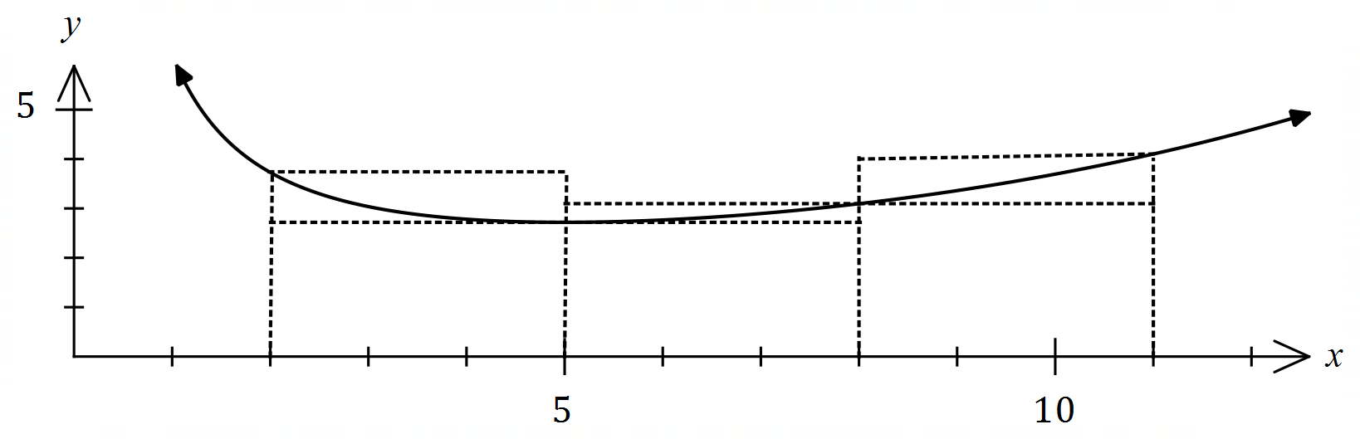

(a) Complete the missing values in the table below, rounding to $2$ decimal places. (1 mark)

|  |
| --- |
| **Solution** |
| See table |
| **Specific behaviours** |
| ✓ both correct |

|  |  |  |  |  |
| --- | --- | --- | --- | --- |
|  |  |  |  |  |
|  |  |  |  |  |

*An easy question for those that can substitute values and use their ClassPad! Both parts correct was necessary to get the single mark.*

(b) Use the areas of the rectangles shown on the graph to determine an under- and over-estimate for $\int_{2}^{11}{\underset{ }{\overset{ }{f(x)}}}dx$. (3 marks)

|  |
| --- |
| **Solution** |
| $$U=3\left(2.72+2.72+3.1\right)=3×8.54=25.62$$ $$O=3\left(3.73+3.1+4.1\right)=3×10.93=32.79$$ |
| **Specific behaviours** |
| ✓ indicates $δx=3$ ü under-estimate  ü over-estimate |

*Very pleasing to see that students recognised the fact that the change in x was not 1. It was a pity that careless errors cost many students marks here. The most common error was not recognising the same two upper values for the under-estimate.*

(c) Use your answers to part (b) to obtain an estimate for $\int_{2}^{11}{\underset{ }{\overset{ }{f(x)}}}dx$. (1 mark)

|  |
| --- |
| **Solution** |
| $$E=\left(25.62+32.79\right)÷2≈29.2$$ |
| **Specific behaviours** |
| ✓ correct mean |

*An easy mark that was also accorded a follow-through mark as long as the average calculation was shown.*

(d) State whether your estimate in part (c) is too big or too small and suggest a modification to the numerical method employed to obtain a more accurate estimate. (2 marks)

|  |
| --- |
| **Solution** |
| Estimate is too big ( $f(x)$ is concave upwards).  Better estimate can be found using a larger number of thinner rectangles. |
| **Specific behaviours** |
| ✓ states too big  ü indicates modification to improve estimate |

*Well done.*

Question 13 (8 marks)

A bag contains four similar balls, one coloured red and three coloured green. A game consists of selecting two balls at random, one after the other and with the first replaced before the second is drawn. The random variable $X$ is the number of red balls selected in one game.

(a) Complete the probability distribution for $X$ below. (3 marks)

|  |  |  |  |
| --- | --- | --- | --- |
|  |  |  |  |
|  |  |  |  |

|  |
| --- |
| **Solution** |
| $$P\left(X=0\right)={\left(\frac{3}{4}\right)}^{2}=\frac{9}{16}; P\left(X=2\right)={\left(\frac{1}{4}\right)}^{2}=\frac{1}{16}; P\left(X=1\right)=1-\frac{9+1}{16}=\frac{6}{16}$$ $$(0.5625, 0.375, 0.0625)$$ |
| **Specific behaviours** |
| ✓ one correct probability  ü probabilities have sum of $1$ ✓ all correct probabilities |

*This should have been an easy three marks for everyone who understood the procedure required. There was sufficient time here to do the problem in a number of ways. Done well overall.*

(b) Determine $E(X)$ and $\operatorname{Var}{(X)}$. (2 marks)

|  |
| --- |
| **Solution** |
| $$E\left(X\right)=0+\frac{6}{16}+\frac{2}{16}=\frac{1}{2}; \operatorname{Var}\left(X\right)=\frac{3}{8}=0.375$$*NB Using CAS, $sd=\frac{\sqrt{6}}{4}≈0.6124$* . |
| **Specific behaviours** |
| ✓ expected value  ✓ variance |

*Done well. However, there were many students who then proceeded to find the standard deviation?*

(c) A player wins a game if the two balls selected have the same colour. Determine the probability that a player wins no more than three times when they play five games.

(3 marks)

|  |
| --- |
| **Solution** |
| $$Y\sim B\left(5,\frac{10}{16}\right)$$ $$P\left(Y≤3\right)≈0.6185$$ |
| **Specific behaviours** |
| ✓ defines distribution  ü states probability required  ü correct probability |

*Not done well. This is a very common type of question. The problem for many was the calculation/recognition of the correct probability for ‘same colour’. There were a couple of ways to calculate the correct answer.*

Question 14 (8 marks)

A curve has equation $y=\left(x-3\right)e^{2x}$.

(a) Show that the curve has only one stationary point and use an algebraic method to determine its nature. (3 marks)

|  |
| --- |
| **Solution** |
| $$y^{'}=2xe^{2x}-5e^{2x} \\ =e^{2x}\left(2x-5\right)$$ For stationary point, require $y^{'}=0$ and since $e^{2x}≠0$ then $x=2.5$- there is only one stationary point. $$y^{''}=4xe^{2x}-8e^{2x}$$ $$x=2.5⇒y^{''}=2e^{5}$$ Hence stationary point is a local minimum. |
| **Specific behaviours** |
| ✓ first derivative  ü uses factored form to justify one stationary point  ü indicates minimum using derivatives (sign or 2nd) |

*Pleased that most recognised the need to use the Product Rule – and a couple of ways of getting the correct answer. Some forgot to show the ‘nature’ of the stationary point, but this part was generally well done.*

(b) Justify that the curve has a point of inflection when $x=2$. (3 marks)

|  |
| --- |
| **Solution** |
| $$y^{''}=4e^{2x}\left(x-2\right) \\ y^{''}(2)=4e^{2(2)}\left(2-2\right)=0$$ |
| **Specific behaviours** |
| ✓ shows second derivative is zero  ü explains justification |

*This was far too easy to be worth 3 marks!*

(c) Sketch the curve on the axes below. (2 marks)

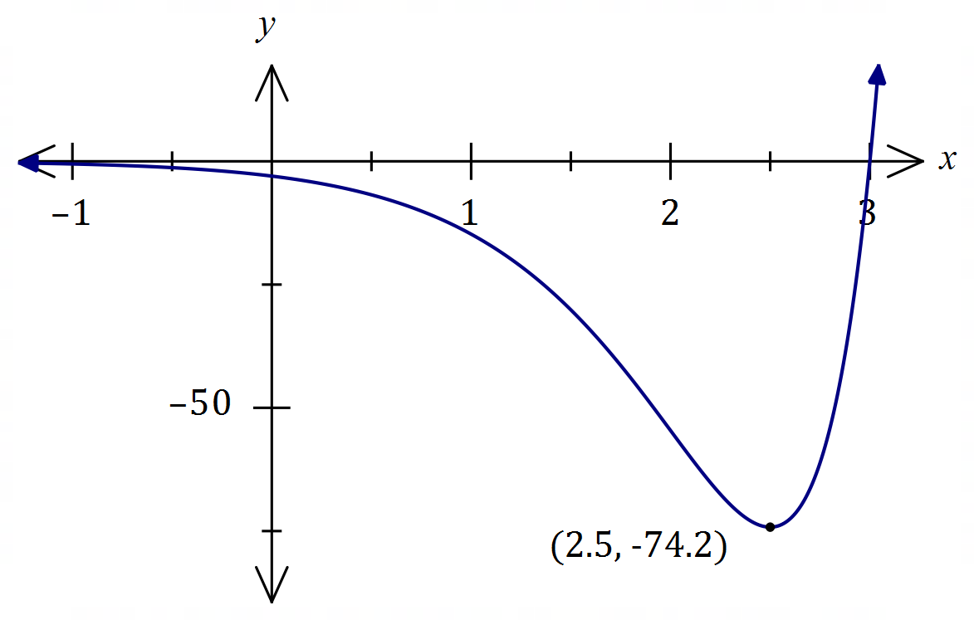

|  |
| --- |
| **Solution** |
| See graph |
| **Specific behaviours** |
| ✓ minimum, $y$-intercept  ü correct shape |

*As the equation was provided in the question and the ClassPad is available – how could you not get three marks for this question? Some didn’t !!!*

Question 15 (9 marks)

A small body leaves point $P$ and travels in a straight line for $24$ seconds until it reaches point $Q$.

The velocity $v$ m/s of the body is shown in the graph below for $0≤t≤24$ seconds.

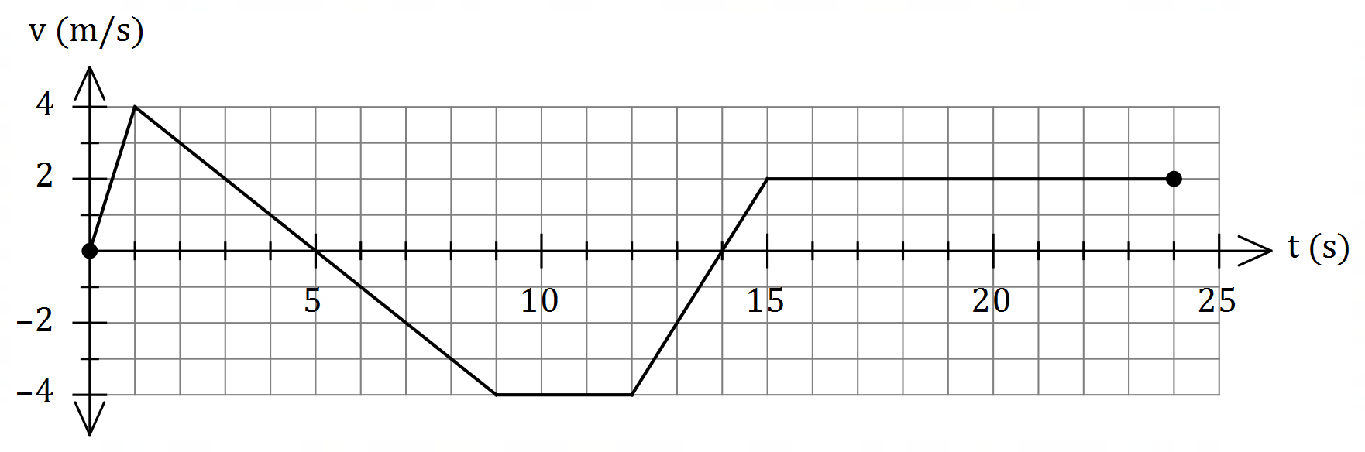

(a) Use the graph to evaluate $\int_{0}^{5}{\underset{ }{\overset{ }{v}}}dt$ and interpret your answer with reference to the motion of the small body. (3 marks)

|  |
| --- |
| **Solution** |
| $$\int_{0}^{5}{v}dt=\frac{1}{2}×5×4=10 \text{m}$$ The change in displacement of the body during the first $5$ seconds is $10$ m.  OR  The body has moved $10$ m to the right of $P$ during first $5$ seconds. |
| **Specific behaviours** |
| ✓ value of integral  ü interprets as change in displacement  ü includes specific time and distance with units in interpretation |

*The lack of understanding in this whole question was obvious. The inability to ‘read’ the question and understand what was required was also apparent. In this part, many students resorted to paragraphs about velocity and acceleration and missed the fundamental part of a V-T graph which is area is equal to displacement. It was necessary to mention ‘displacement’, to the right 10m AND how long it took! Words such as ‘forwards’ or ‘backwards’ are unacceptable unless the words are defined relative to the question.*

(b) Determine an expression, in terms of $t$, for the displacement of the body relative to $P$ during the interval $1≤t≤9$. (3 marks)

|  |
| --- |
| **Solution** |
| $$v=5-t⇒x=\int{5-t}dt=5t-0.5t^{2}+c$$ $$t=1,x=2⇒2=5\left(1\right)-{0.5\left(1\right)}^{2}+c⇒c=-2.5$$ $$x=5t-{0.5t}^{2}-2.5, 1≤t≤9$$ |
| **Specific behaviours** |
| ✓ expression for $v$ ü expression for $x$ with constant $c$ ü correct expression for $x$ |

*Finding ‘c’ proved to be the major obstacle here, even if the student was able to identify the ‘line’ being considered. As with a couple of other parts in this examination, students needed a comprehensive understanding of linear equations.*

(c) Determine the time(s) at which the body was at point $P$ for $0<t≤24$. (3 marks)

|  |
| --- |
| **Solution** |
| $$x\left(9\right)=10+\frac{1}{2}×4×\left(-4\right)=2$$ $$2-4\left(t-9\right)=0⇒t=9.5$$ $$x\left(15\right)=-13$$ $$-13+2\left(t-15\right)=0⇒t=21.5$$ Body at point $P$ when $t=9.5$ s and $t=21.5$ s. |
| **Specific behaviours** |
| ✓ indicates appropriate method using areas  ü one correct time  ü two correct times |

*If equating positive and negative areas was recognised as the appropriate method, it should have enabled students to get full marks here but that, unfortunately, was not the case.*

Question 16 (9 marks)

When a machine is serviced, between $2$ and $6$ of its parts are replaced. Records indicate that $28\%$ of machines need $4$ parts replaced, $13\%$ need $5$ parts replaced, $5\%$ need $6$ parts replaced, and the mean number of parts replaced per service is $3.54$.

Let the random variable $X$ be the number of parts that need replacing when a randomly selected machine is serviced.

(a) Complete the probability distribution table for $X$ below. (4 marks)

|  |  |  |  |  |  |
| --- | --- | --- | --- | --- | --- |
|  |  |  |  |  |  |
|  |  |  |  |  |  |

|  |
| --- |
| **Solution** |
| Let $P\left(x=2\right)=a, P\left(X=3\right)=b$ then $$0.46+a+b=1 \\ 2a+3b+1.12+0.65+0.3=3.54$$ Hence $$a=0.15, b=0.39$$ |
| **Specific behaviours** |
| ✓ values for $x=4, 5, 6$ ü equation using sum of probabilities  ü equation using expected value  ü values for $x=2, 3$ |

*Filling in the table was worth two marks and showing the simultaneous equations needed to be shown for the other two marks. This part was done well and the whole question proved to be one of the easiest on the whole paper.*

|  |
| --- |
| **Solution** |
| Using CAS, $σ=1.0528058$ Hence $Var\left(X\right)=σ^{2}=1.1084$ |
| **Specific behaviours** |
| ✓ indicates sd using CAS  ü correct variance |

(b) Determine $Var⁡(X)$. (2 marks)

*An easy two marks with the use of the ClassPad.*

The cost of servicing a machine is $\$85$ plus $\$26.50$ per part replaced and the random variable $Y$ is the cost of servicing a randomly selected machine.

(c) Determine the mean and standard deviation of $Y$. (3 marks)

|  |
| --- |
| **Solution** |
| $$Y=85+26.5X$$ $$E\left(Y\right)=85+26.5×3.54=\$178.81$$ $$σ_{Y}=26.5×1.0528≈\$27.90$$ |
| **Specific behaviours** |
| ✓ equation relating $X$ and $Y$ ü mean  ü standard deviation (penalty no units: $-1$ mark) |

*Some students were penalised a mark here for not showing the $ sign twice or giving answers to more than two decimal places. Otherwise, done very well.*

Question 17 (6 marks)

Some values of the polynomial function $f$ are shown in the table below:

|  |  |  |  |  |  |  |  |
| --- | --- | --- | --- | --- | --- | --- | --- |
| $$x$$ | $$1$$ | $$2$$ | $$3$$ | $$4$$ | $$5$$ | $$6$$ | $$7$$ |
| $$f(x)$$ | $$16$$ | $$13$$ | $$8$$ | $$2$$ | $$-2$$ | $$1$$ | $$5$$ |

(a) Evaluate $\int_{1}^{6}{\underset{ }{\overset{ }{f'(x)}}}dx$. (2 marks)

|  |
| --- |
| **Solution** |
| $$\int_{1}^{6}{f^{'}\left(x\right)}dx=f\left(6\right)-f\left(1\right) \\ =1-16 \\ =-15$$ |
| **Specific behaviours** |
| ✓ uses fundamental theorem  ü correct value |

*This was done very poorly. Students showed a complete lack of understanding regarding the FFT of calculus. The only thing that needed to be recognised was that the integral of a derivative, results in the original function. By using the equation that is provided on the Formula Sheet it was merely a question of substitution!*

The following is also known about $f'(x)$:

|  |  |  |  |
| --- | --- | --- | --- |
| Interval | $$1≤x≤5$$ | $$x=5$$ | $$5≤x≤7$$ |
| $$f'(x)$$ | $$f^{'}\left(x\right)<0$$ | $$f^{'}\left(x\right)=0$$ | $$f^{'}\left(x\right)>0$$ |

(b) Determine the area between the curve $y=f'(x)$ and the $x$-axis, bounded by $x=2$ and $x=7$. (4 marks)

|  |
| --- |
| **Solution** |
| Area to right of $x=5$ is above axis but to left is below so will need to negate/drop negative sign for that integral: $$\text{Area}=-\int_{2}^{5}{f^{'}\left(x\right)}dx+\int_{5}^{7}{f^{'}\left(x\right)}dx \\ =-\left[f\left(5\right)-f\left(2\right)\right]+\left[f\left(7\right)-f\left(5\right)\right] \\ =f\left(2\right)+f\left(7\right)-2f\left(5\right) \\ =13+5-2\left(-2\right) \\ =22 \text{sq units}$$ |
| **Specific behaviours** |
| ü integral for $f^{'}\left(x\right)<5$ ü negated integral for $f^{'}\left(x\right)>5$ ü uses fundamental theorem  ü correct area |

*Most missed the fact that there were two parts to the function. Any student who tried to do this in one step did not consider the fact it was worth 4 marks.*

Question 18 (8 marks)

Let $P(a, b)$ be a point in the first quadrant that lies on the curve $y=5-x^{2}$ and $A$ be the area of the triangle formed by the tangent to the curve at $P$ and the coordinate axes.

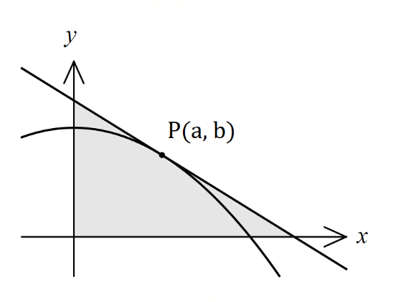

(a) Show that $A=\begin{matrix}{\left(a^{2}+5\right)}^{2} \\ \overline{ 4a }\end{matrix}$. (4 marks)

|  |
| --- |
| **Solution** |
| Gradient at $P$: $$\frac{dy}{dx}=-2x⇒m_{P}=-2a$$ Equation of tangent: $$y=-2ax + c \\ b=5 - a^{2}$$ $$⇒5 -{ a}^{2} ={-2a}^{2}+c$$ $$⇒c =a^{2}+5$$ Thus $y=-2ax + a^{2}+5$ Axes intercepts: $$y=0⇒x=\frac{a^{2}+5}{2a}, x=0⇒y=a^{2}+5$$ Area: $$A=\frac{1}{2}\left(\frac{a^{2}+5}{2a}\right)\left(a^{2}+5\right)=\frac{{\left(a^{2}+5\right)}^{2}}{4a}$$ |
| **Specific behaviours** |
| ✓ in terms of $a$ and $m_{P}$ ü equation of tangent in terms of $a, x, y$ (any form)  ü axes intercepts  ü indicates area of right triangle |

*Very poorly done and not surprising given the fact that it was quite a unique question that expected students to remember a lot about intersections, gradient, intercepts, etc. It was more a question of algebraic manipulation rather than a straight calculus question. The focus was on finding the area of a triangle, so it was necessary to find the base and the height. This simple fact was missed by almost everyone, which resulted in a range of algebraic nonsense that went nowhere.*

(b) Use calculus to determine the coordinates of $P$ that minimise $A$. (4 marks)

|  |
| --- |
| **Solution** |
| Hence $P\left(\frac{\sqrt{15}}{3},\frac{10}{3}\right)≈P(1.291, 3.333)$ |
| **Specific behaviours** |
| ✓ first derivative  ü solves for $a$ ü indicates check for minimum (graph, sign or second derivative test)  ü correct coordinates, exact or at least $2$ dp |

*This question allowed students to get half the marks for the whole question because the function that needed differentiating was provided in part (a). Most were successful in getting the x-value but then made a mistake in getting the other ordinate. It was pleasing to see that students generally showed the fact that the point was a minimum.*

Question 19 (7 marks)

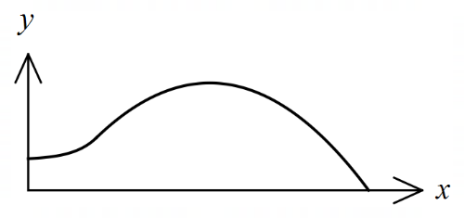The edges of a swimming pool design, when viewed  
from above, are the $x$-axis, the $y$-axis and the curves

$y=-0.1x^{2}+1.6x-1.5$ and $y=1.4+e^{x-3}$

where $x$ and $y$ are measured in metres.

(a) Determine the gradient of the curve at the point where the two curves meet. (2 marks)

|  |
| --- |
| **Solution** |
| Curves intersect when $x=3$ $$y^{'}=-0.2\left(3\right)+1.6=e^{3-3}=1$$ |
| **Specific behaviours** |
| ✓ -coordinate of intersection  ü correct gradient |

*An easy two marks for those with sufficient algebra skills. Failure to get the correct x value for the intersection affected other parts of the question and consumed time that did not match the worth of the question.*

(b) Determine the surface area of the swimming pool. (4 marks)

|  |
| --- |
| **Solution** |
| $$A_{1}=\int_{0}^{3}{1.4+e^{x-3}}dx=\frac{26}{5}-\frac{1}{e^{3}}≈5.15$$ $$A_{2}=\int_{3}^{15}{-0.1x^{2}+1.6x-1.5}dx=\frac{216}{5}=43.2$$ $$A_{1}+A_{2}=\frac{242}{5}-\frac{1}{e^{3}}≈48.35 {\text{m}}^{2}$$ |
| **Specific behaviours** |
| ✓ upper bound for parabola  ü area $A_{1}$ ü area $A_{2}$ ü total area, with units |

*Many students made a reasonable attempt at this question as it was clear what was being asked. However, the use of algebra caused issues and many students got only one of the two parts correct.*

(c) Given that the water in the pool has a uniform depth of $145$ cm, determine the capacity of the pool in kilolitres ( $1$ kilolitre of water occupies a volume of m3). (1 mark)

|  |
| --- |
| **Solution** |
| $$C=48.35×1.45≈70.1 \text{kL}$$ |
| **Specific behaviours** |
| ✓ correct capacity |

*Many students forgot to convert units and ended up with some VERY large pools. Being only worth one mark, it was difficult to give any follow-through marks when answers are so obviously unreasonable.*

Question 20 (6 marks)

Given that $f\left(3\right)=9, f^{'}\left(3\right)=-6, g\left(3\right)=-2$ and $g^{'}\left(3\right)=4$, evaluate $h'(3)$ in each of the following cases:

(a) $h\left(x\right)=g\left(x\right)⋅f(x)$. (2 marks)

|  |
| --- |
| **Solution** |
| $$h^{'}\left(3\right)=g^{'}\left(3\right)×f\left(3\right)+g\left(3\right)×f^{'}\left(3\right) \\ =4×9+\left(-2\right)×\left(-6\right) \\ =48$$ |
| **Specific behaviours** |
| ✓ uses product rule  ü correct value |

*By far this was the question that caused the most problems for students. The concern here is the fact that students completely ignored the skills of basic algebra and failed to see it was just the Product Rule of differentiation with all the values provided. There hasn’t been a problem like this on previous papers, so students failed to even recognise what was required.*

(b) $h\left(x\right)=g\left(\sqrt{f\left(x\right)}\right)$. (4 marks)

|  |
| --- |
| **Solution** |
| $$\frac{d}{dx}\sqrt{f\left(x\right)}=\frac{1}{2\sqrt{f\left(x\right)}}⋅f^{'}\left(x\right)$$ $$h^{'}\left(x\right)=g^{'}\left(\sqrt{f\left(x\right)}\right)×\frac{1}{2\sqrt{f\left(x\right)}}⋅f^{'}\left(x\right) \\ h^{'}\left(3\right)=g^{'}\left(\sqrt{f(3)}\right)×\frac{1}{2\sqrt{f(3)}}×f'(3)$$ $$=g^{'}\left(\sqrt{9}\right)×\frac{1}{2\sqrt{9}}×(-6) \\ =g'(3)×(-1) \\ =-4$$ |
| **Specific behaviours** |
| ✓ uses chain rule on $\sqrt{f\left(x\right)}$ ü correct derivative of inside  ü uses chain rule again  ü substitutes and simplifies |

*Similar to part (a) but now with the Chain rule (twice) and a couple of extra steps!!*

Question 21 (8 marks)

When a byte of data is sent through a network in binary form (a sequence of bits - $0$'s and $1$'s), there is a chance of bit errors that corrupt the byte, i.e. a $0$ becomes a $1$ and vice versa.

Suppose a byte consists of a sequence of $9$ bits and for a particular network, the chance of a bit error is $0.200\%.$

(a) Determine the probability that a byte is transmitted without corruption, rounding your answer to $5$ decimal places. (3 marks)

|  |
| --- |
| **Solution** |
| $$X\sim B(9, 0.002)$$ $$P\left(X=0\right)=0.98214$$ |
| **Specific behaviours** |
| ✓ indicates binomial distribution  ü indicates probability to calculate  ü correct probability, to $5$ dp |

*Generally done well and was interpreted correctly by most. Full marks were given for just the correct answer as this could be done quite easily on the ClassPad.*

(b) Determine the probability that during the transmission of $128$ bytes, at least one of the bytes becomes corrupted. (2 marks)

|  |
| --- |
| **Solution** |
| $$Y\sim B\left(128, 0.01786\right)$$ $$P\left(Y≥1\right)=0.9004$$ |
| **Specific behaviours** |
| ✓ indicates correct method  ü correct probability |

*There were a few interpretations of the question here due to the wording and therefore a couple of correct ways of getting the answer.*

A Hamming code converts a byte of $9$ bits into a byte of $13$ bits for transmission, with the advantage that if just one bit error occurs during transmission, it can be detected and corrected.

(c) Determine the probability that during the transmission of $128$ bytes using Hamming codes, at least one of the bytes becomes permanently corrupted. (3 marks)

|  |
| --- |
| **Solution** |
| $$H\sim B\left(13, 0.002\right)$$ $$P\left(H≥2\right)=0.00031$$ $$M\sim B\left(128, 0.00031\right)⇒P\left(M≥1\right)=0.0386$$ |
| **Specific behaviours** |
| ü states distribution of failures of a $13$ bit byte  ✓ probability that single Hamming code byte corrupted  ü correct probability |

*Not done well – largely due to the interpretation of the question. There were a number of ‘distractors’ in the wording that meant students were unsure of what was actually being asked.*

Supplementary page

Question number: _________